LAB – 02

Implement programmability objects with SQL
Estimated Time: 45 minutes
In this exercise you will create and use core SQL Server programmability objects to centralize logic and improve maintainability:
- Create a view to simplify complex queries
- Write a stored procedure to encapsulate a business operation
- Implement a scalar function for reusable calculations
- Build an inline table-valued function (TVF) for parameterized result sets
- Add a trigger to automatically respond to data changes
📝 These exercises ask you to copy and paste T-SQL code. Please verify that the code has been copied correctly, before executing the code.
Prerequisites
- SQL Server 2019+ or Azure SQL Database
- A query tool such as SQL Server Management Studio
- A connection with CREATE permissions
- AdventureWorks lightweight sample database (SQL Server or Azure SQL)

Connect to AdventureWorksLT
Ensure the AdventureWorksLT sample database is restored and available on your SQL instance. Verify connectivity and some key tables:
- Copy and paste the following T-SQL code into a new query window. Select Execute to execute this query.

sqlTypeCopy
-- Verify key tables in AdventureWorksLT
SELECT TOP (5) CustomerID, FirstName, LastName
FROM SalesLT.Customer;

SELECT TOP (5) SalesOrderID, OrderDate, CustomerID
FROM SalesLT.SalesOrderHeader;

SELECT TOP (5) ProductID, Name, ListPrice
FROM SalesLT.Product;

RESULT:
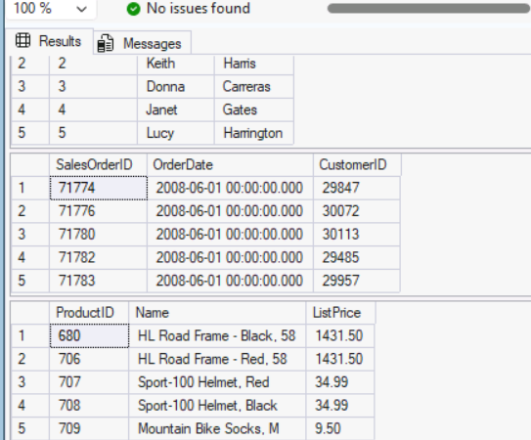

Each query should return up to five rows of sample data. The first result set displays customer names, the second shows recent orders with dates and customer references, and the third lists products with their prices. If any query returns no rows or fails, confirm that the AdventureWorksLT database is properly restored and that you have read access.

Create a view to simplify queries
Create a view that combines customers and their orders in AdventureWorksLT (SalesLT schema). This hides JOIN complexity from application code.
- Copy and paste the following T-SQL code into a new query window. Select Execute to create the view.
sqlTypeCopy
CREATE OR ALTER VIEW SalesLT.vCustomerOrders AS
SELECT
c.CustomerID,
CONCAT(c.FirstName, ' ', c.LastName) AS CustomerName,
h.SalesOrderID,
h.OrderDate
FROM SalesLT.Customer c
INNER JOIN SalesLT.SalesOrderHeader h ON c.CustomerID = h.CustomerID;

RESULT:
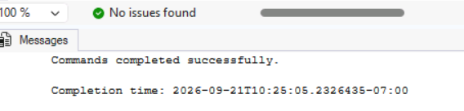
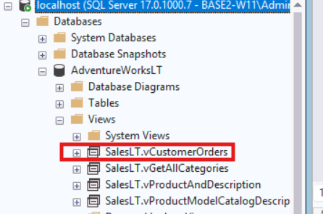

- Validate the view. Execute the following query.
sqlTypeCopy
SELECT TOP (5) *
FROM SalesLT.vCustomerOrders
ORDER BY OrderDate DESC;

RESULT:
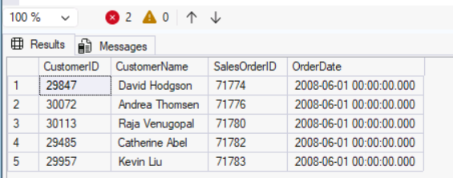
The query returns up to five rows showing the most recent orders. Each row includes a CustomerID, the customer's full name, the SalesOrderID, and the OrderDate, demonstrating how the view simplifies access to joined customer and order data.

Create a stored procedure to process an order
Encapsulate a business operation that adds an order line item to an existing order in AdventureWorksLT and updates the header subtotal.
- Copy and paste the following T-SQL code into a new query window. Select Execute to create the stored procedure.
sqlTypeCopy
CREATE OR ALTER PROCEDURE dbo.AddOrderLineItem
@SalesOrderID INT,
@ProductID INT,
@Quantity INT
AS
BEGIN
SET NOCOUNT ON;
BEGIN TRANSACTION;

-- Use Product ListPrice as UnitPrice
DECLARE @UnitPrice DECIMAL(18,2);
SELECT @UnitPrice = CAST(ListPrice AS DECIMAL(18,2))
FROM SalesLT.Product
WHERE ProductID = @ProductID;

IF @UnitPrice IS NULL
BEGIN
ROLLBACK TRANSACTION;
THROW 50010, 'Invalid ProductID specified.', 1;
END

-- Ensure SalesOrderID exists
IF NOT EXISTS (SELECT 1 FROM SalesLT.SalesOrderHeader WHERE SalesOrderID = @SalesOrderID)
BEGIN
ROLLBACK TRANSACTION;
THROW 50011, 'Invalid SalesOrderID specified.', 1;
END

-- Insert line item (no discount)
INSERT INTO SalesLT.SalesOrderDetail (SalesOrderID, OrderQty, ProductID, UnitPrice, UnitPriceDiscount)
VALUES (@SalesOrderID, @Quantity, @ProductID, @UnitPrice, 0);

-- Update header subtotal based on current line totals
UPDATE h
SET SubTotal = d.SumLineTotal,
ModifiedDate = SYSUTCDATETIME()
FROM SalesLT.SalesOrderHeader h
INNER JOIN (
SELECT SalesOrderID, SUM(LineTotal) AS SumLineTotal
FROM SalesLT.SalesOrderDetail
WHERE SalesOrderID = @SalesOrderID
GROUP BY SalesOrderID
) d ON d.SalesOrderID = h.SalesOrderID;

COMMIT TRANSACTION;
END;

RESULT:
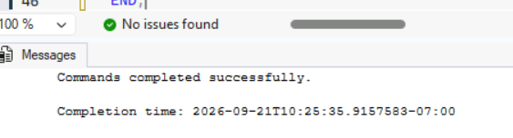
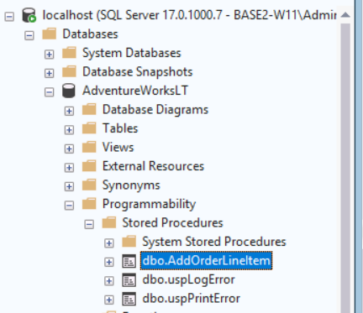

This stored procedure performs a transactional insert of a new line item. It first validates that the product and order exist--rolling back and throwing an error if either is invalid. After inserting the detail row with the product's list price, it recalculates the order's subtotal from all line items and updates the header. Wrapping everything in a transaction ensures the operation is atomic: either all changes succeed or none are applied.

- Execute the following T-SQL code to test the stored procedure.
sqlTypeCopy
-- Add a line item to an existing order (choose a valid SalesOrderID)
DECLARE @SalesOrderID INT = (SELECT TOP 1 SalesOrderID
FROM SalesLT.SalesOrderHeader
ORDER BY SalesOrderID DESC);
EXEC dbo.AddOrderLineItem @SalesOrderID = @SalesOrderID,
@ProductID = 680,
@Quantity = 1; -- adjust ProductID as needed

SELECT TOP (5) *
FROM SalesLT.SalesOrderDetail
WHERE SalesOrderID = @SalesOrderID
ORDER BY SalesOrderDetailID DESC;

SELECT SalesOrderID, SubTotal, TaxAmt, Freight, TotalDue
FROM SalesLT.SalesOrderHeader
WHERE SalesOrderID = @SalesOrderID;

RESULT:
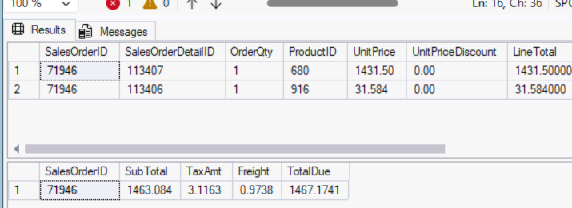

Create a scalar function for reusable calculations
Create a scalar function that returns the total value of an order using AdventureWorksLT line totals.
- Copy and paste the following T-SQL code into a new query window. Select Execute to create the function.
sqlTypeCopy
CREATE OR ALTER FUNCTION dbo.fnOrderTotal (@OrderID INT)
RETURNS DECIMAL(18,2)
AS
BEGIN
DECLARE @Total DECIMAL(18,2);

SELECT @Total = SUM(LineTotal)
FROM SalesLT.SalesOrderDetail
WHERE SalesOrderID = @OrderID;

RETURN ISNULL(@Total, 0.00);
END;

RESULT:
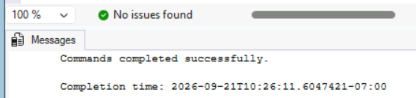

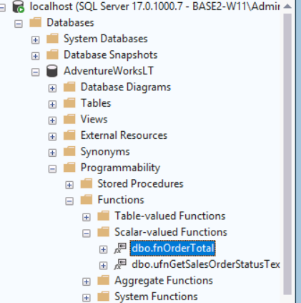

- Execute the following T-SQL code to use the function:
sqlTypeCopy
SELECT d.SalesOrderID, dbo.fnOrderTotal(d.SalesOrderID) AS OrderTotal
FROM SalesLT.SalesOrderDetail d
GROUP BY d.SalesOrderID
ORDER BY d.SalesOrderID DESC;

RESULT:
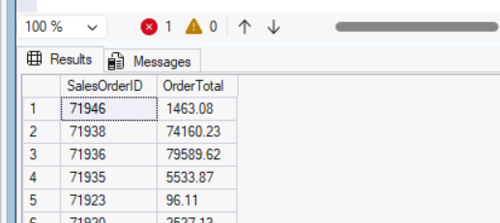

Create an inline table-valued function (TVF)
Build a TVF to return orders for a given customer from AdventureWorksLT. TVFs are handy in SELECT and JOIN clauses.
- Copy and paste the following T-SQL code into a new query window. Select Execute to create the TVF.
sqlTypeCopy
CREATE OR ALTER FUNCTION dbo.GetCustomerOrders (@CustomerID INT)
RETURNS TABLE
AS
RETURN
(
SELECT
h.SalesOrderID,
h.OrderDate
FROM SalesLT.SalesOrderHeader h
WHERE h.CustomerID = @CustomerID
);

RESULT:
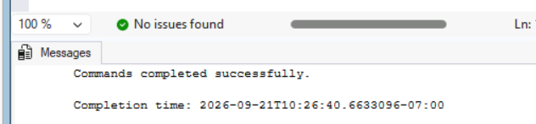

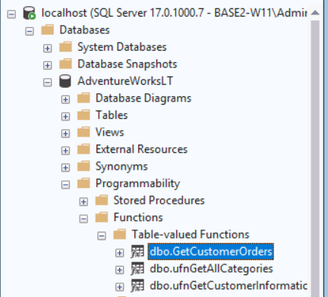

- Execute the following T-SQL code to query the function.
sqlTypeCopy
SELECT *
FROM dbo.GetCustomerOrders(29929)
ORDER BY OrderDate DESC;

RESULT:
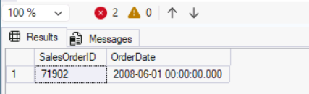

- Execute the following T-SQL code to join the function to customers:
sqlTypeCopy
SELECT CONCAT(c.FirstName, ' ', c.LastName) AS CustomerName, o.SalesOrderID, o.OrderDate
FROM SalesLT.Customer c
CROSS APPLY dbo.GetCustomerOrders(c.CustomerID) o
WHERE c.CustomerID = 29929;

RESULT:
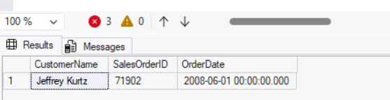

Create a trigger to log changes
Add a trigger that logs updates to order totals when SalesLT order details change. Triggers help enforce rules or capture audit trails automatically.

- Copy and paste the following T-SQL code into a new query window. Select Execute to create the audit table and trigger.

sqlTypeCopy
-- Audit table
IF OBJECT_ID('dbo.OrderAudit') IS NULL
BEGIN
CREATE TABLE dbo.OrderAudit (
AuditID INT IDENTITY(1,1) PRIMARY KEY,
OrderID INT NOT NULL,
OldTotal DECIMAL(18,2) NULL,
NewTotal DECIMAL(18,2) NULL,
ChangedAt DATETIME2 NOT NULL DEFAULT SYSUTCDATETIME()
);
END
GO

-- Trigger on order details updates
CREATE OR ALTER TRIGGER SalesLT.trg_LogOrderTotalChange
ON SalesLT.SalesOrderDetail
AFTER INSERT, UPDATE
AS
BEGIN
SET NOCOUNT ON;

;WITH AffectedOrders AS (
SELECT SalesOrderID FROM inserted
UNION
SELECT SalesOrderID FROM deleted
),
-- New totals from the base table (already reflects changes)
NewTotals AS (
SELECT d.SalesOrderID, SUM(d.OrderQty * d.UnitPrice) AS Total
FROM SalesLT.SalesOrderDetail d
INNER JOIN AffectedOrders a ON d.SalesOrderID = a.SalesOrderID
GROUP BY d.SalesOrderID
),
-- Contribution of the newly inserted/updated rows
InsertedTotals AS (
SELECT SalesOrderID, SUM(OrderQty * UnitPrice) AS Total
FROM inserted
GROUP BY SalesOrderID
),
-- Contribution of the previous row versions (empty on INSERT)
DeletedTotals AS (
SELECT SalesOrderID, SUM(OrderQty * UnitPrice) AS Total
FROM deleted
GROUP BY SalesOrderID
)
INSERT INTO dbo.OrderAudit (OrderID, OldTotal, NewTotal)
SELECT
n.SalesOrderID,
n.Total - ISNULL(i.Total, 0) + ISNULL(d.Total, 0) AS OldTotal,
n.Total AS NewTotal
FROM NewTotals n
LEFT JOIN InsertedTotals i ON n.SalesOrderID = i.SalesOrderID
LEFT JOIN DeletedTotals d ON n.SalesOrderID = d.SalesOrderID;
END;

RESULT:
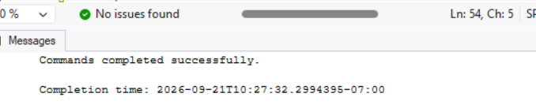
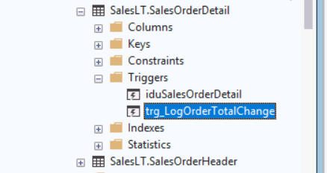

- Execute the following T-SQL code to test the trigger:
sqlTypeCopy
-- Update an order detail to change the total
UPDATE d
SET OrderQty = OrderQty + 1
FROM SalesLT.SalesOrderDetail d
WHERE d.SalesOrderID = (SELECT TOP 1 SalesOrderID FROM SalesLT.SalesOrderHeader ORDER BY SalesOrderID DESC);

SELECT TOP (5) *
FROM dbo.OrderAudit
ORDER BY AuditID DESC;

RESULT:
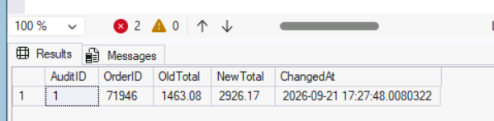

The SELECT statement returns recent rows from the audit table. Each row shows the OrderID that was affected, the previous total (OldTotal), the new total (NewTotal) after the quantity change, and a timestamp. This confirms the trigger automatically logged the modification.

Cleanup
If you are not using the database or the lab files for any other purpose, you can clean up the objects you created in this lab.
- From the lab virtual machine or your local machine if one wasn't provided, start a SQL Server Management Studio session (SSMS).
- When SSMS opens, by default the Connect to Server dialog will appear. Choose the Default instance and select Connect. You might need to check the Trust server certificate checkbox.
- In Object Explorer, expand the Databases folder.
- Right-click on the AdventureWorksLT database and select Delete.
- In the Delete Object dialog, check the Close existing connections checkbox.
- Select OK.
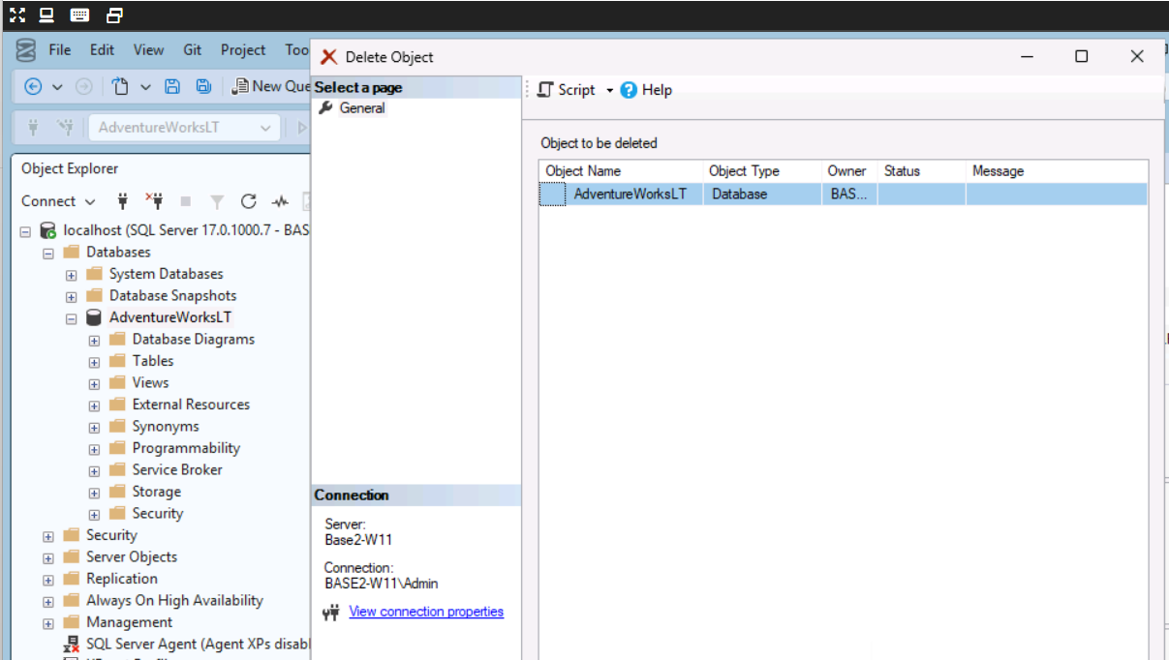

Next steps
- Consider adding indexes to improve performance of JOIN operations and filter predicates.
- Extend the stored procedure to handle multiple line items per order.
- Add permissions to expose the view safely to end users.

You have successfully completed this exercise.
In this exercise, you learned how to implement core SQL Server programmability objects, including views to simplify complex queries, stored procedures to encapsulate transactional business logic, scalar functions for reusable calculations, inline table-valued functions for parameterized result sets, and triggers to automatically capture audit trails when data changes.

Congratulations
You have successfully completed this lab. Click End to mark the lab as Complete.

